Importing EnviroCOMS project details into Researchdata (RedBox).

Prior to downloading, review the Project details in EnviroCOMS. Ensure all possible fields are completed.

1. Log into Envirocoms

<http://tdh-envirocoms-1.hpc.jcu.edu.au/login>

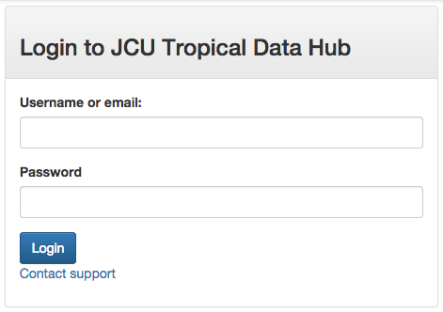

1. Select ‘EnviroCOMS Admin’.

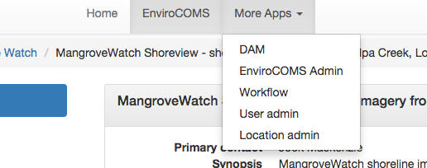

1. Select ‘Add-ons’

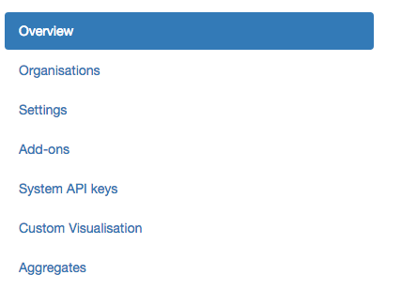

1. Select ‘JCU eRC Project Management’

*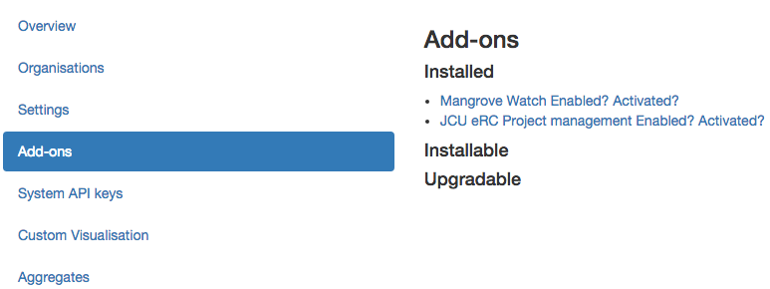*

1. Click on ‘Download’ for the appropriate project.
   1. The file will open a new tab in your browser.
   2. Right click on the page and select ‘View Page Source’
   3. This again will open a new tab, using your web browser, ‘File, Save As’.
   4. The file must be given a unique name. Suggested format is ‘envirocoms###.xml’ where ‘XXX’ represents a consecutive number. The file name must be unique for the importation process for each new project.
2. Import the file into redbox.
   1. Copy the file to redbox.hpc.jcu.edu.au /opt/repo/deployment/redbox/home/harvest/enmasse-alerts
   2. Run the new-alerts job. <https://research.jcu.edu.au/researchdata/default/hkjobs/newalerts.script>
   3. This will start the job. All going well the record will appear in ‘Published’, after curation has completed. Review the record and update where appropriate.